

NQUTHU LOCAL MUNICIPALITY

POLICY ON VIREMENT

2025-26

TABLE OF CONTENTS

- Definitions

- OBJECTIVE

- VIREMENT CLARIFICATION

4. DELEGATION OF VIREMENT POWERS AND DUTIES

5. SUB-DELEGATION

- VIREMENT PROCESS

- VIREMENT RESTRICTIONS

- DEFINITIONS
  - In this policy, unless the context indicates otherwise, the following definitions are applied –
    - ‘Accounting Officer’ means the Municipal Manager for the Municipality within the meaning of Section 82 of the Municipal Structures Act, 1998 (Act No.117 of 1998);
    - ‘CFO’ means Chief Financial Officer;
    - ‘MFMA’ means the Municipal Finance Management Act (Act No. 56 of 2003);
    - ‘Senior manager’ is an official reporting directly to the accounting officer;
    - ‘Virement’ means the transfer of budgetary provision from one budget head to another budget head

- OBJECTIVE
The Nquthu Local Municipality resolves in terms of the MFMA to implement a virement policy that -
    - enables the council, Executive Committee, Portfolio Committees, accounting officer, senior managers and their staff, to manage budgets with a degree of flexibility within the overall policy framework determined by the council; and
    - Optimises the use of resources by ensuring adequate funding is available to defray expenditure that is incurred in a particular vote or sub-vote, by offsetting savings in another vote or sub-vote or additional revenue.

- VIREMENT CLARIFICATION
Virement must consider the implications of possible mSCOA segment changes taking place because of the virement (the moving of budgetary allocations within a function or its sub-functions). If virement result in a mSCOA segment change, by adding a new project, changing the region or funding source, it is not allowed.

- DELEGATION OF VIREMENT POWERS AND DUTIES
  - The council hereby delegates such additional powers and duties to the accounting officer so as to enable the accounting officer –
    - to discharge the financial management responsibilities conferred on him in terms of –
      - Chapter 8 of the MFMA; and
      - ensuring an effective control system for this virement policy;
    - to maximise administrative and operational efficiency in the implementation of the virement policy;
  - Sections 79 and 106 of the MFMA apply to the sub-delegation of powers and duties delegated to an accounting officer in terms of paragraph 3.1 of this policy.
  - The council or accounting officer may not delegate or sub-delegate any virement powers or duties to a person who is not an official of the municipality.

- SUB-DELEGATIONS
  - The council hereby delegates authority to the accounting officer to approve virements within and between sub-votes up to 25% of the total sub-vote.
  - The accounting officer may in terms of section 79 or 106 of the MFMA sub-delegate any virement responsibilities, including those delegated to the accounting officer in terms of this policy, but any such sub-delegation must be consistent with other provisions within this policy.
  - The power to approve a virement –
    - between votes may not be sub-delegated except as outlined in paragraph 5.1;

- VIREMENT PROCESS
  - All virement proposals must be completed on the appropriate documentation and forwarded to the Accounting Officer or delegated person for checking.
  - All virements must be signed by the Director of the directorate within which the Project is allocated. (Section 79 MFMA).
  - Virements between Projects must be approved in advance of their implementation, except in the case of an emergency as determined by the accounting officer including, but not limited to, –
    - unforeseen and unavoidable expenditure for which no provision was made in the budget; and
    - expenditure in relation to cases of emergency as described in the municipality’s supply chain management policy, in which case the accounting officer must agree the virement.
  - Any transfer of funds in sections (Cost Centre) by the Accounting Officer must inform in writing by comments from the HOD and the CFO
  - Projected cash flows in the SDBIP should be adjusted in line with the virement.

- VIREMENT RESTRICTIONS
- A Project extending over/ incorporating more than one mSCOA function or sub function, then savings in the budgetary allocation in a function or sub-function may be applied across the functions and/ or sub-functions directly linked to the same Project and Funding Source;
- Where the Finance and Administrative function or sub function is directly linked to another Function or sub function, then savings in the linked function/ sub-function may be applied in the Finance and Administrative function or vice versa2. Therefore, virement between Rates Services and Trading Services and across Trading Service are not allowed;
- Virements should not be permitted in relation to the revenue side of the budget;
- Virements between functions should be permitted where the proposed shifts in funding facilitate sound risk and financial management
- Virements from the capital budget to the operating budget should not be permitted, Operational funds to the Capital Budget may be done, but only via an Adjustments budget;
- Virements towards personnel expenditure should not be permitted, except where:
  - temporary/ contracted (budget for as contracted services in terms to the mSCOA Classification) staff status has changed to permanent staff; or
  - the budget savings resulted from Outsourced Services within the same function in terms of a Council delegated authority).

- Virements to or from the following items should not be permitted: bulk purchases; debt impairment, interest charges; depreciation, grants to individuals, revenue foregone, insurance and VAT;
- Virements should not result in adding ‘new’ projects to the Capital Budget;
- Virements of conditional grant funds to purposes outside of that specified in the relevant conditional grant framework must not be permitted; and
- There should be prudent limits on the amount of funds that may be moved between a function and its sub-functions. In terms of national best practise, a maximum percentage of 25% of the budget of a Function/ programme/ project may be re-allocated/ shifted through virement
- Specifies the principles and the maintenance (aligning with mSCOA) for the keeping of records of any budgetary movements.
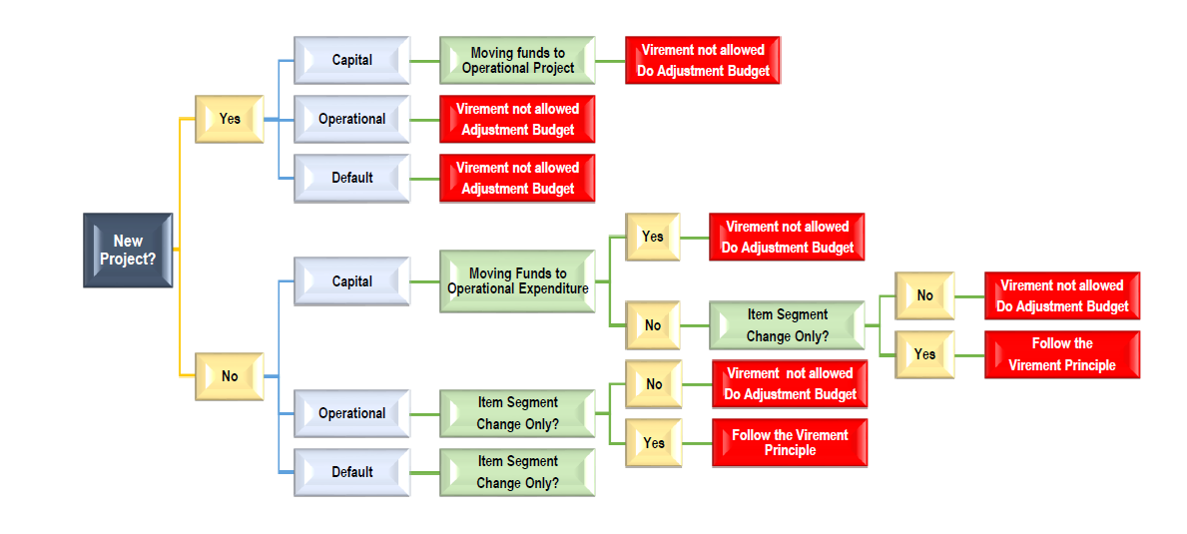

AMENDMENTS AND REVIEW OF POLICY
The policy may be reviewed at any time during the financial year, and the implementation date is 01 July 2025.

